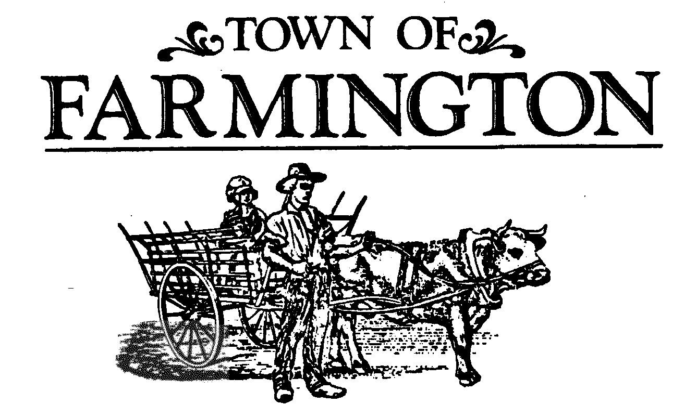

***Zoning Board of Appeals Meeting Agenda***

***August 25, 2025, Meeting***

***7:00pm***

**THIS MEETING WILL BE HELD IN THE MAIN MEETING ROOM, AT THE TOWN HALL, 1000 COUNTY ROAD 8, FARMINGTON, NEW YORK 14425. THOSE NOT WISHING TO ATTEND MAY PARTICIPATE VIRTUALLY IN THE MEETING BEING CONDUCTED SIMULTANEOUSLY AT THAT TIME ON-LINE, OR OVER THE PHONE.**

**Join Zoom Meeting by clicking the following link:**

<https://zoom.us/j/95476695857?pwd=dWVyODUxN1lNNlhXZ2NXZUVtUnRKUT09>

Meeting ID: 954 7669 5857

Passcode: 678772

One tap mobile

+16465588656, 95476695857#, *678772# US (New York)

Dial by your location

+1 646 558 8656 US (New York)

Meeting ID: 954 7669 5857

Passcode: 678772

Find your local number: <https://zoom.us/u/aeHVeyDjKe>

1. Open Meeting, Identify Rules of Procedure, Emergency Evacuation Procedures, Introductions of Board Members & Staff —Chairperson Yourch.
2. Approval of Meeting Minutes, June 23, 2025, and July 28th, 2025, Meeting.
3. Attest to publishing legal notices – the following Legal Notices for tonight’s agenda were published in the Daily Messenger on August 19, 2025:

**LEGAL NOTICE**

**NOTICE IS HEREBY GIVEN THAT** the Zoning Board of Appeals of the Town of Farmington, will conduct 6 Public Hearings on the **25th day of August 2025,** commencing at 7:00 p.m., in the Farmington Town Hall, Main Meeting Room, 1000 County Road 8, Farmington, New York, 14425 for the purpose ofreceiving testimony upon and considering the applications of:

ZB 2025-0701, Bridges for Brain Injury, 1111 County Rd 8 Farmington NY 14425: Requesting an area variance for Tax Map Account 30.00-1-61.100 to allow relief from the Town Code requirement [Chapter 165, Article V, §55] that the keeping of animals shall not be closer than 200 feet to all side or rear lot lines as a Type II Action. The applicant is proposing a side set back of thirty-six feet. The property is zoned R-1-15.

ZB 2025-0702, Bridges for Brain Injury, 1111 County Rd 8 Farmington NY 14425: Requesting an area variance for Tax Map Account 30.00-1-61.100 to allow relief from the Town Code requirement [Chapter 165, Article V, §55] that the storage of any farm animal waste or other odor-or dust – producing materials shall not be closer than 200 feet to any lot lines as a Type II Action. The applicant is proposing a side yard setback of fifty feet and a rear yard setback of ninety-five feet. The property is zoned R-1-15.

ZB 2025 0703, Alan Benedict, 89 Bowerman Rd Farmington NY 14425: Requesting an area variance for Tax Map Account 1.15-1-69.100 to allow relief from the Town Code requirement [Chapter 165, Schedule I] minimum side setback is 15 feet. The applicant is proposing a setback of 8 feet for a garage addition of 12 feet by 22 feet. The property is zoned RS-25.

ZB 2025 0704, Adrian Bellis, 5540 Holtz Road Farmington NY 14425: Requesting an area variance for Tax Map Account 9.03-1-6.400 to allow relief from the Town Code requirement [Chapter 165 Section 10] to construct an Accessory Structure containing a total of 4,230 square feet in area. The Town Code defines an Accessory Structure~~s~~ shall be subordinate in area, extent or purpose to the principal building or principal use served; contributes to the comfort, convenience or necessity of occupants of the principal building or principal use. The property is zoned A-80 Agricultural.

ZB 2025 0705, T&M Properties of WNY, LLC (Villager Construction) 1 Capron Street, Union St, Unit 3C, Rochester, NY 14607: Requesting an area variance for relief from the Town Code requirement [Chapter 165, Article IV, Section 34] that sidewalks are to be provided on **a** subject site fronting along State and Town highways withing the mapped (MTOD) Major Thoroughfare Overlay District that connect to, or contribute to, the completion of a pedestrian network in the area. The property islocated at Loomis Road and is zoned GI General Industrial and MTOD Major Thoroughfare Overlay District.

ZB 2025 0706, Ryan Berner, 1796 Opal Dr Farmington NY 14425: Requesting an area variance for Tax Map Account 17.00-1-67.700 to allow relief from the Town Code requirement [Chapter 165-58 (A). All accessory structures in any zoning district shall be located in the rear yard portion of a lot having a principal structure and shall have a minimum rear yard setback of five feet. The applicant is proposing a 10-foot by 12-foot shed. The property is zoned RS-25 Residential Suburban.

**ALL PARTIES IN INTEREST** will be given an opportunity to be heard in respect to such applications. Persons may appear in person, or by agent or via Zoom.

By order of:

Thomas Yourch, Chairman, Town of Farmington Zoning Board of Appeals

Publication: Daily Messenger, August 19, 2025

1. **CONTINUED PUBLIC HEARING(S):**

ZB 2025-0602, Adrian Bellis, 5540 Holtz Road Farmington NY 14425: Requesting an area variance for Tax Map Account 9.03-1-6.400 to allow relief from the Town Code requirement [Chapter 165 Section 58- B] Accessory structures shall have a maximum height of 15 feet as measured from existing grade to the peak of the roof of the accessory structure. The applicant is requesting an accessory structure with a maximum height of 25 feet as measured from existing grade to the peak of the roof of the accessory structure. The property is zoned A-80 Agricultural.

1. **PUBLIC HEARINGS:**

ZB 2025-0701, Bridges for Brain Injury, 1111 County Rd 8 Farmington NY 14425: Requesting an area variance for Tax Map Account 30.00-1-61.100 to allow relief from the Town Code requirement [Chapter 165, Article V, §55] that the keeping of animals shall not be closer than 200 feet to all side or rear lot lines as a Type II Action. The applicant is proposing a side set back of thirty-six feet. The property is zoned R-1-15.

ZB 2025-0702, Bridges for Brain Injury, 1111 County Rd 8 Farmington NY 14425: Requesting an area variance for Tax Map Account 30.00-1-61.100 to allow relief from the Town Code requirement [Chapter 165, Article V, §55] that the storage of any farm animal waste or other odor-or dust – producing materials shall not be closer than 200 feet to any lot lines as a Type II Action. The applicant is proposing a side yard setback of fifty feet and a rear yard setback of ninety-five feet. The property is zoned R-1-15.

ZB 2025 0703, Alan Benedict, 89 Bowerman Rd Farmington NY 14425: Requesting an area variance for Tax Map Account 1.15-1-69.100 to allow relief from the Town Code requirement [Chapter 165, Schedule I] minimum side setback is 15 feet. The applicant is proposing a setback of 8 feet for a garage addition of 12 feet by 22 feet. The property is zoned RS-25.

ZB 2025 0704, Adrian Bellis, 5540 Holtz Road Farmington NY 14425: Requesting an area variance for Tax Map Account 9.03-1-6.400 to allow relief from the Town Code requirement [Chapter 165 Section 10] to construct an Accessory Structure containing a total of 4,230 square feet in area. The Town Code defines an Accessory Structures shall be subordinate in area, extent or purpose to the principal building or principal use served; contributes to the comfort, convenience or necessity of occupants of the principal building or principal use. The property is zoned A-80 Agricultural.

ZB 2025 0705, T&M Properties of WNY, LLC (Villager Construction) 1 Capron Street, Union St, Unit 3C, Rochester, NY 14607: Requesting an area variance for relief from the Town Code requirement [Chapter 165, Article IV, Section 34] that sidewalks are to be provided on **a** subject site fronting along State and Town highways withing the mapped (MTOD) Major Thoroughfare Overlay District that connect to, or contribute to, the completion of a pedestrian network in the area. The property islocated at Loomis Road and is zoned GI General Industrial and MTOD Major Thoroughfare Overlay District.

ZB 2025 0706, Ryan Berner, 1796 Opal Dr Farmington NY 14425: Requesting an area variance for Tax Map Account 17.00-1-67.700 to allow relief from the Town Code requirement [Chapter 165-58 (A). All accessory structures in any zoning district shall be located in the rear yard portion of a lot having a principal structure and shall have a minimum rear yard setback of five feet. The applicant is proposing a 10-foot by 12-foot shed. The property is zoned RS-25 Residential Suburban.

1. **BOARD DELIBERATIONS AND DECISIONS:**

**ZB #2025-0701 Bridges for Brain Injury Area Variance**

**1111 County Rd 8**

**Farmington, NY 14425**

**ZB #2025-0702 Bridges for Brain Injury Area Variance**

**1111 County Rd 8**

**Farmington NY 14425**

**ZB #2025-0703 Alan Benedict Area Variance**

**89 Bowerman Road**

**Farmington, NY 14425**

**ZB #2025-0602 Adrian Bellis Area Variance**

**5540 Holtz Road**

**Farmington NY 14425**

**ZB #2025-0704 Adrian Bellis Area Variance**

**5540 Holtz Road**

**Farmington NY 14425**

**ZB #2025-0705 Villager Construction Area Variance**

**Loomis Road**

**Farmington NY 14425**

**ZB #2025-0706 Ryan Berner Area Variance**

**1796 Opal Dr**

**Farmington NY 14425**

**7. OTHER BOARD MATTERS:**

**8. PUBLIC COMMENTS—OPEN FORUM DISCUSSION**

1. **DIRECTOR OF DEVELOPMENT UPDATE**
2. **ZONING / CODE ENFORCEMENT OFFICER UPDATE**
3. **NEXT MEETING DATE:** September 29, 2025
4. **ADJOURNMENT:**